**Name: AKASH**

**Uid : 22BCS17064  
section: FL_Iot 603 ‘A’**

**1.**[**Convert Sorted Array to Binary Search Tree**](https://leetcode.com/problems/convert-sorted-array-to-binary-search-tree/description/)

class Solution {

public:

TreeNode* sortedArrayToBST(vector<int>& nums) {

return build(nums, 0, nums.size() - 1);

}

private:

TreeNode* build(const vector<int>& nums, int l, int r) {

if (l > r)

return nullptr;

const int m = (l + r) / 2;

return new TreeNode(nums[m], build(nums, l, m - 1), build(nums, m + 1, r));

}

};

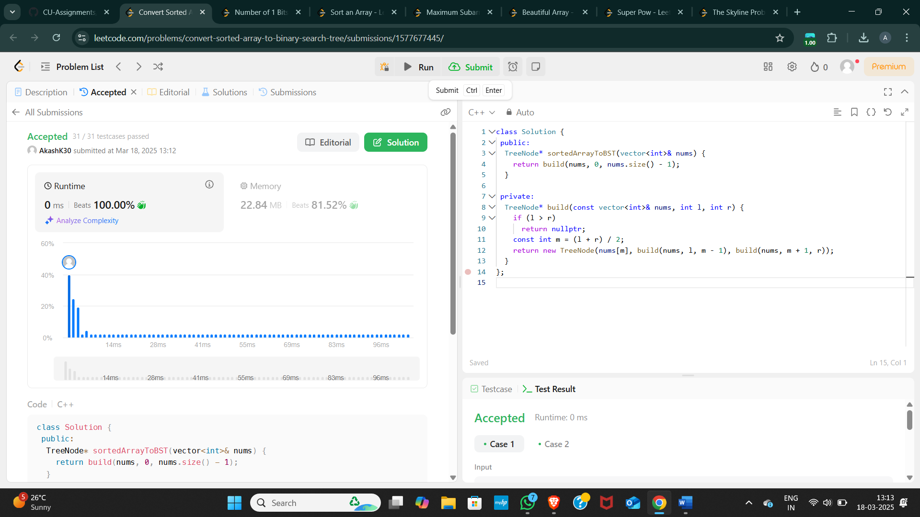

2. [Number of 1 Bits](https://leetcode.com/problems/number-of-1-bits/description/)

class Solution {

public:

int hammingWeight(uint32_t n) {

int ans = 0;

for (int i = 0; i < 32; ++i)

if ((n >> i) & 1)

++ans;

return ans;

}

};

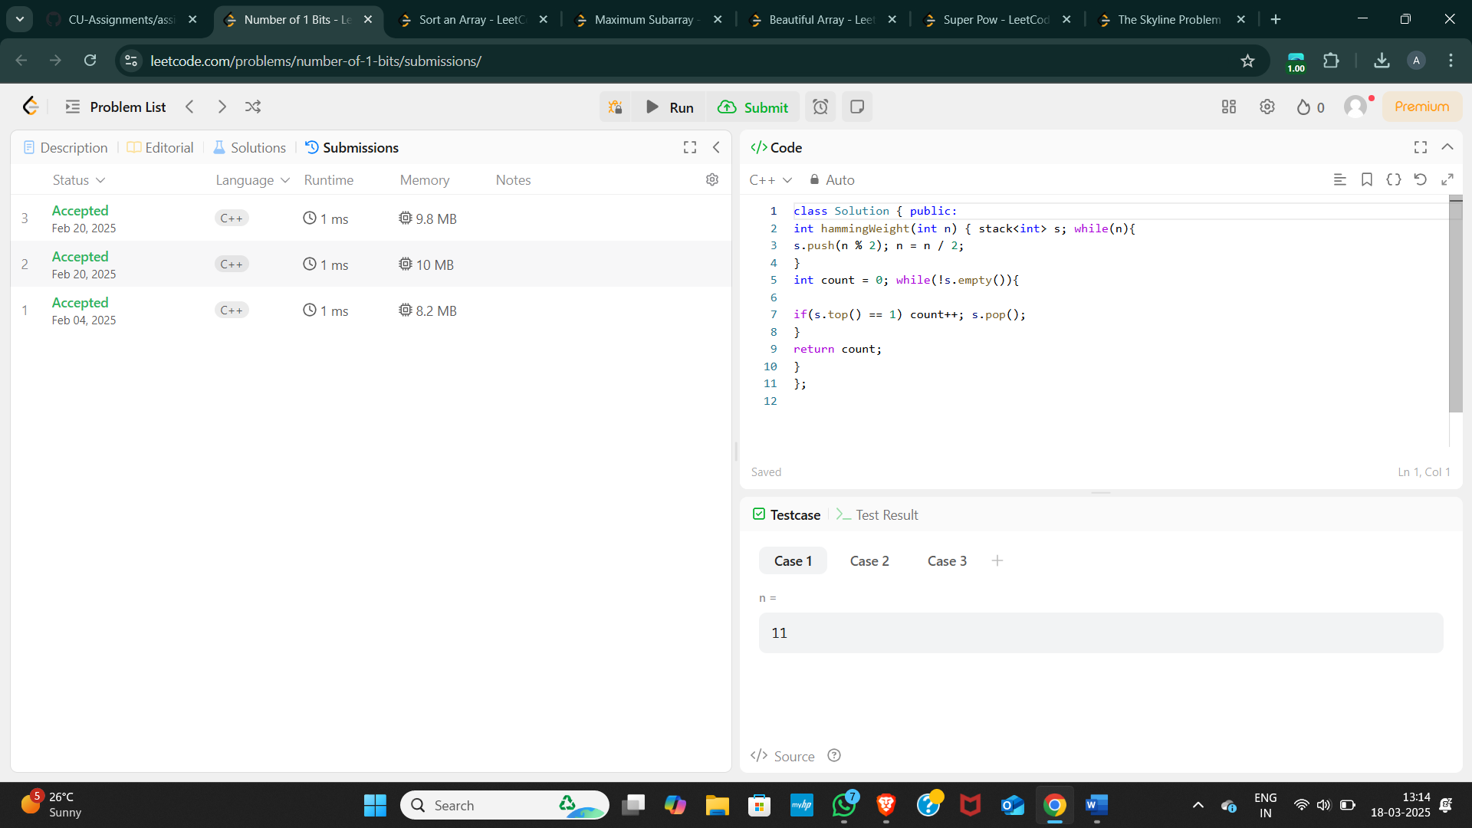

3. [Sort an Array](https://leetcode.com/problems/sort-an-array/description/)

class Solution {

 public:

  vector<int> sortArray(vector<int>& nums) {

    mergeSort(nums, 0, nums.size() - 1);

    return nums;

  }

 private:

  void mergeSort(vector<int>& nums, int l, int r) {

    if (l >= r)

      return;

    const int m = (l + r) / 2;

    mergeSort(nums, l, m);

    mergeSort(nums, m + 1, r);

    merge(nums, l, m, r);

  }

  void merge(vector<int>& nums, int l, int m, int r) {

    vector<int> sorted(r - l + 1);

    int k = 0;

    int i = l;

    int j = m + 1;

    while (i <= m && j <= r)

      if (nums[i] < nums[j])

        sorted[k++] = nums[i++];

      else

        sorted[k++] = nums[j++];

    while (i <= m)

      sorted[k++] = nums[i++];

    while (j <= r)

      sorted[k++] = nums[j++];

    copy(sorted.begin(), sorted.end(), nums.begin() + l);

  }

};

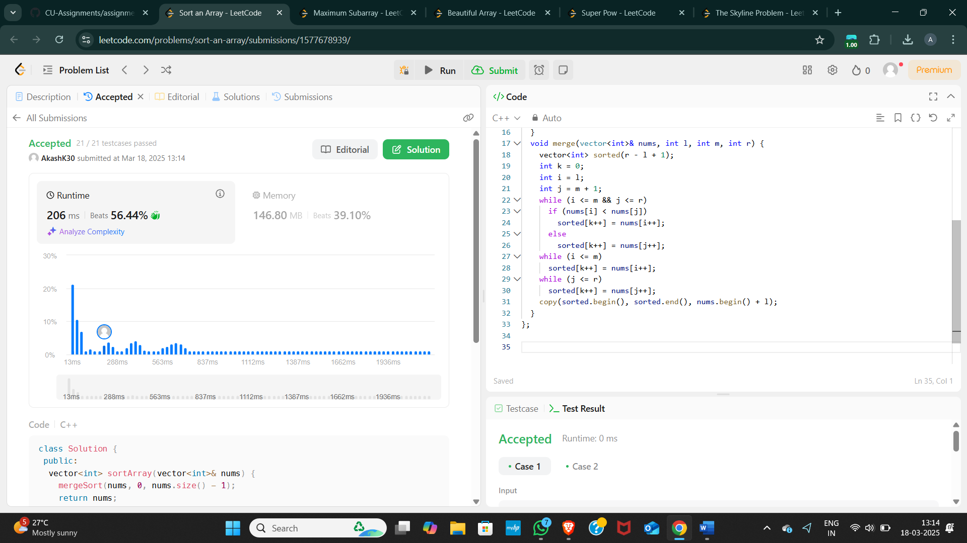

4. [Maximum Subarray](https://leetcode.com/problems/maximum-subarray/description/)

class Solution { public:

int maxSubArray(vector<int>& arr) {

long long maxi = LONG_MIN; // maximum sum

long long sum = 0;

int n = arr.size();

for (int i = 0; i < n; i++) {

sum += arr[i];

if (sum > maxi) { maxi = sum;

}

if (sum < 0) { sum = 0;

}

}

return maxi;

}

};

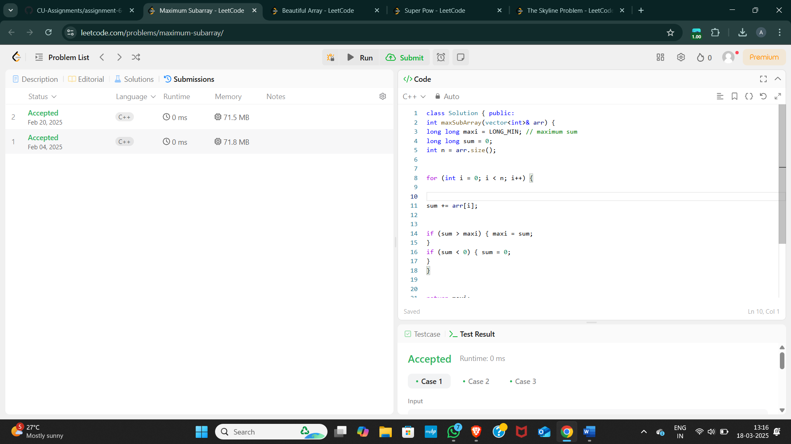

5. [Beautiful Array](https://leetcode.com/problems/beautiful-array/description/)

class Solution {

 public:

  vector<int> beautifulArray(int n) {

    vector<int> arr(n);

    iota(arr.begin(), arr.end(), 1);

    divide(arr, 0, n - 1, 1);

    return arr;

  }

 private:

  void divide(vector<int>& arr, int l, int r, int mask) {

    if (l >= r)

      return;

    const int m = partition(arr, l, r, mask);

    divide(arr, l, m, mask << 1);

    divide(arr, m + 1, r, mask << 1);

  }

  int partition(vector<int>& arr, int l, int r, int mask) {

    int nextSwapped = l;

    for (int i = l; i <= r; ++i)

      if (arr[i] & mask)

        swap(arr[i], arr[nextSwapped++]);

    return nextSwapped - 1;

  }

};

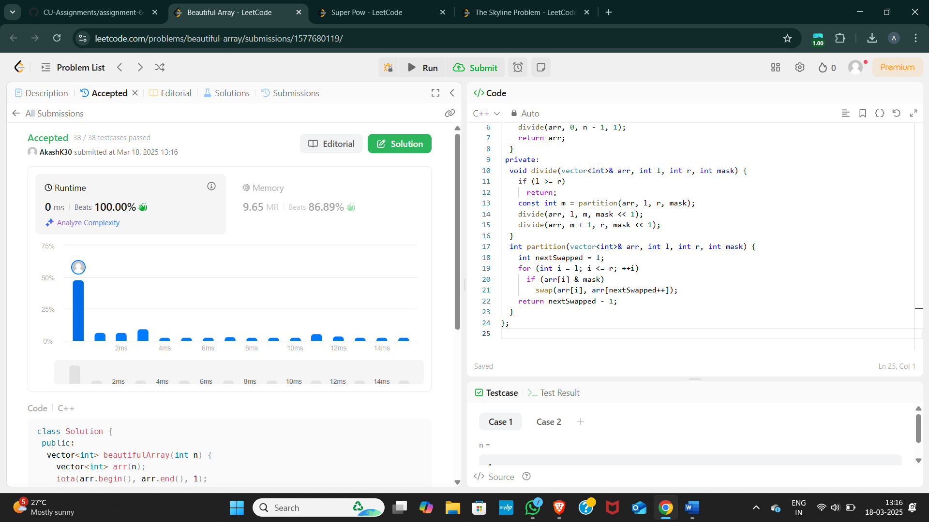

6. [Super Pow](https://leetcode.com/problems/super-pow/description/)

class Solution {

 public:

  int superPow(int a, vector<int>& b) {

    int ans = 1;

    a %= kMod;

    for (const int i : b)

      ans = modPow(ans, 10) * modPow(a, i) % kMod;

    return ans;

  }

 private:

  static constexpr int kMod = 1337;

  long modPow(long x, long n) {

    if (n == 0)

      return 1;

    if (n % 2 == 1)

      return x * modPow(x % kMod, (n - 1)) % kMod;

    return modPow(x * x % kMod, (n / 2)) % kMod;

  }

};

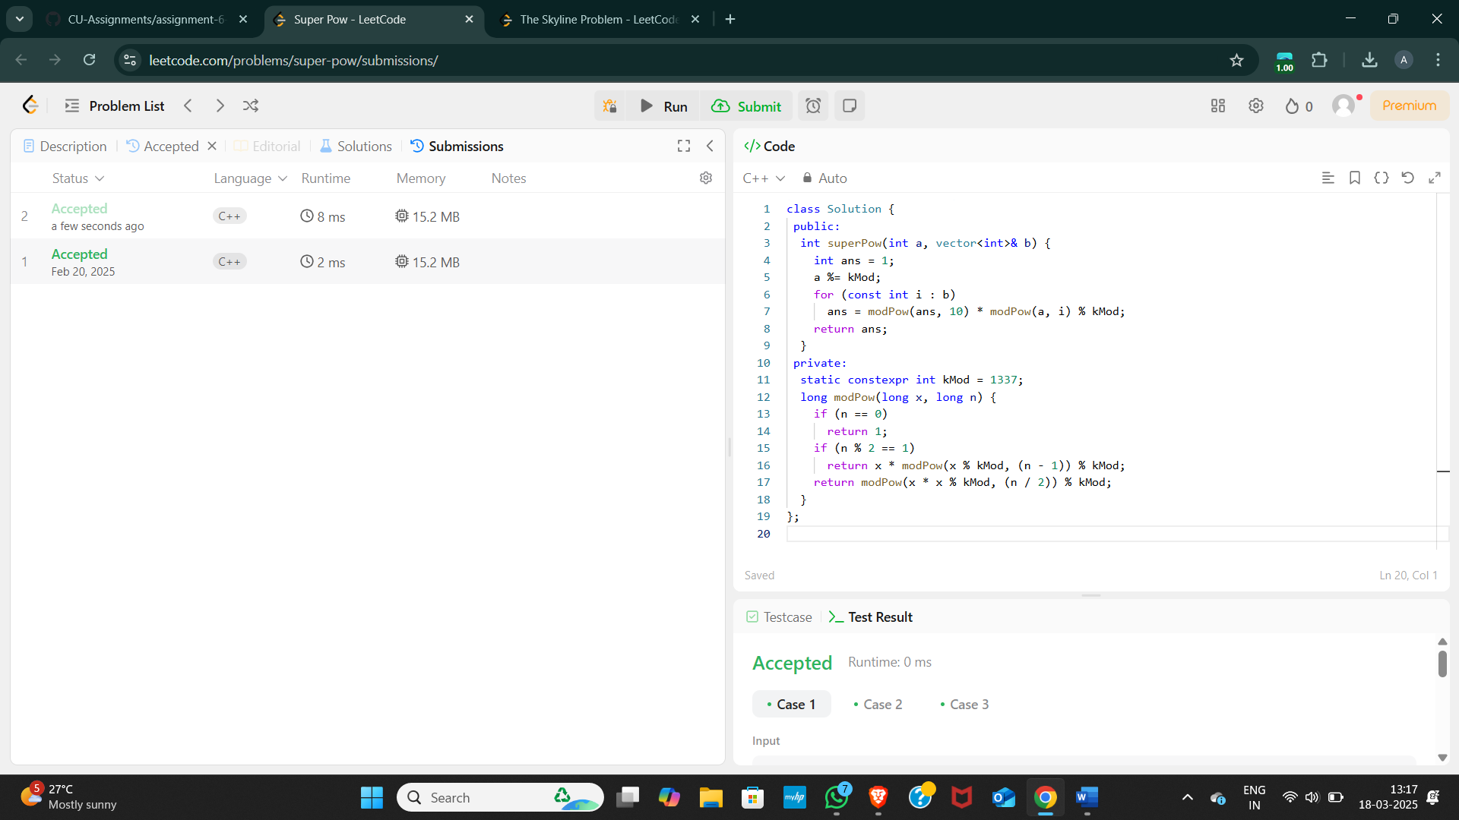

7. [The Skyline Problem](https://leetcode.com/problems/the-skyline-problem/description/)

class Solution {

 public:

  vector<vector<int>> getSkyline(const vector<vector<int>>& buildings) {

    const int n = buildings.size();

    if (n == 0)

      return {};

    if (n == 1) {

      const int left = buildings[0][0];

      const int right = buildings[0][1];

      const int height = buildings[0][2];

      return {{left, height}, {right, 0}};

    }

    const vector<vector<int>> left =

        getSkyline({buildings.begin(), buildings.begin() + n / 2});

    const vector<vector<int>> right =

        getSkyline({buildings.begin() + n / 2, buildings.end()});

    return merge(left, right);

  }

 private:

  vector<vector<int>> merge(const vector<vector<int>>& left,

                            const vector<vector<int>>& right) {

    vector<vector<int>> ans;

    int i = 0;

    int j = 0;

    int leftY = 0;

    int rightY = 0;

    while (i < left.size() && j < right.size())

      if (left[i][0] < right[j][0]) {

        leftY = left[i][1];

        addPoint(ans, left[i][0], max(left[i++][1], rightY));

      } else {

        rightY = right[j][1];

        addPoint(ans, right[j][0], max(right[j++][1], leftY));

      }

    while (i < left.size())

      addPoint(ans, left[i][0], left[i++][1]);

    while (j < right.size())

      addPoint(ans, right[j][0], right[j++][1]);

    return ans;

  }

  void addPoint(vector<vector<int>>& ans, int x, int y) {

    if (!ans.empty() && ans.back()[0] == x) {

      ans.back()[1] = y;

      return;

    }

    if (!ans.empty() && ans.back()[1] == y)

      return;

    ans.push_back({x, y});

  }

};

